



HEALTH ADMINISTRATION PROCEDURES
(610)
STATE 2024

Multiple Choice:
40 @ 3 points each ____________ (120 points)
Production:
Job 1: Patient Letter ___________ (60 points)
Job 2: SOAP Transcription ____________ (60 points)
TOTAL POINTS _____________ (240 points)

Test Time: 60 minutes

GENERAL GUIDELINES:
Failure to adhere to any of the following rules will result in disqualification:
- Member must hand in this test booklet and all printouts if any.
- No equipment, supplies, or materials other than those specified for this event are allowed in the testing area. No previous BPA tests and/or sample tests (handwritten, photocopied, or keyed) are allowed in the testing area.
- Electronic devices will be monitored according to ACT standards.

EXAM GUIDELINES:
- Ensure this test booklet contains Job 1 (Patient Letter) and Job 2 (SOAP Transcription).
- Key all jobs according to the instructions given.
- Correct any and all formatting, spelling or grammar errors. Use the formatting guide in the Style & Reference Manual.
- Your name or initials should not appear on any work you submit. Use your contestant number in any occasion you would normally key your reference initials.
- In the lower right-hand corner of ALL work submitted (unless otherwise specified) key your contestant number and job number.
- If you complete the event before the end of the time allotted, notify the proctor. Time could be considered a factor in determining a winner when there is a tie score.
- Place your scoring sheet on top of your Jobs. Jobs should be in numerical order.

PRODUCTION STANDARDS
0 Errors | 100 Points
1 Error | 90 Points
2 Errors | 70 Points
3 Errors | 50 Points
4+ Errors | 0 Points

Multiple Choice

1. | A
2. | A
3. | B
4. | B
5. | B
6. | B
7. | D
8. | B
9. | A
10. | B
11. | D
12. | C
13. | D
14. | A
15. | C
16. | A
17. | D
18. | C
19. | B
20. | B
21. | B
22. | A
23. | A
24. | D
25. | B
26. | C
27. | B
28. | B
29. | D
30. | D
31. | A
32. | B
33. | A
34. | B
35. | B
36. | C
37. | C
38. | A
39. | A
40. | B

January 01, 2024 (This is an example. Student is to use the date of the exam)

Mr. Matthew Nichols
1213 Hidden Cave Road
San Diego, CA 92251

Dear Mr. Nichols

MISSED APPOINTMENT

Thank you for choosing the Medical Office for your care.
We want to inform you that we have a record of a missed appointment on January 1, 2024. Our No-Show Policy states that after the first missed appointment without notice, subsequent missed appointments will incur a $50 charge.
We wanted to send this letter to remind you of our policy and request that you notify the office within 24 hours if you need to cancel or reschedule your appointments in the future. Please call us at 800-555-0000. Thank you.

Sincerely

Brenda Davis
Medical Office Manager

######### (Member ID Number

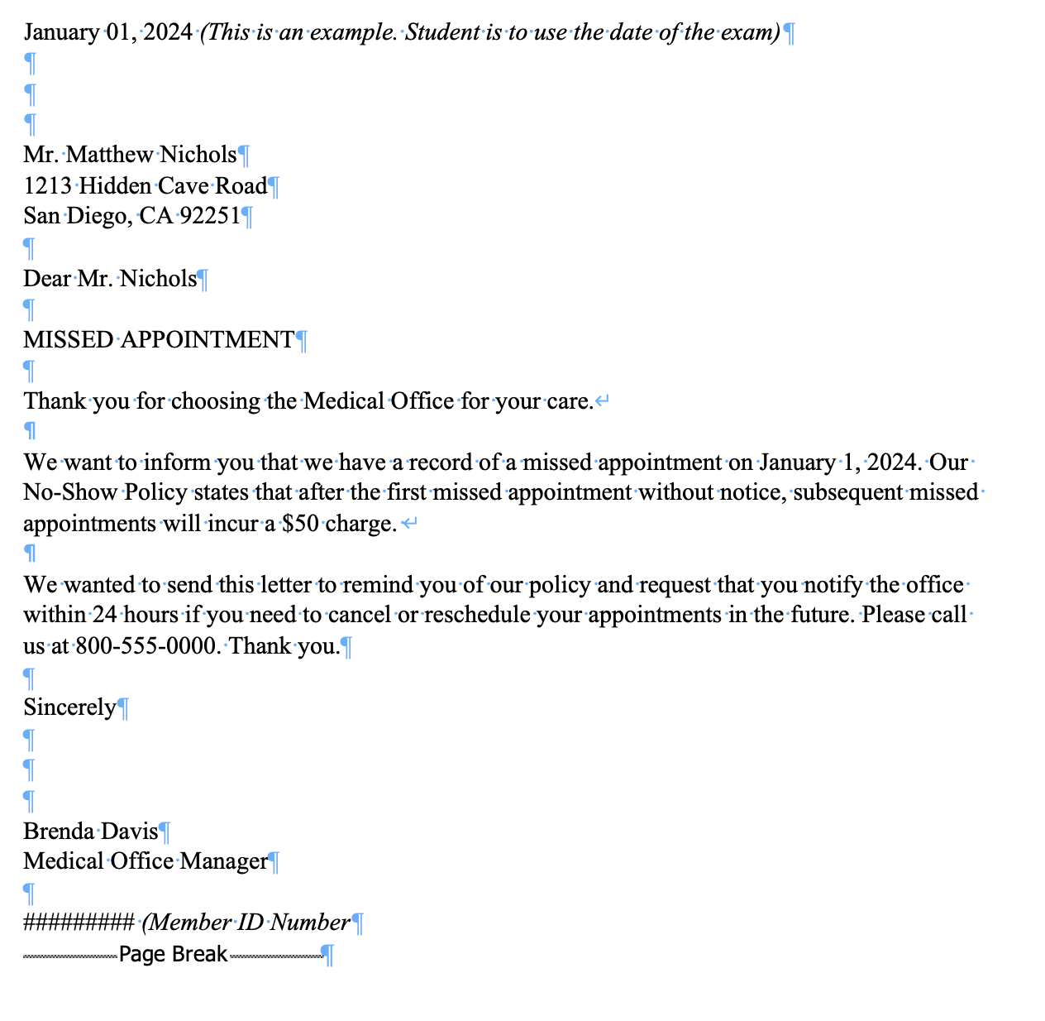

For graders: Refer to the Style and Reference for grading. Ensure that the top margin of the first page is 2 inches. For any subsequent pages the top margins should be 1 inch. All side margins should be 1 inch. Open punctuation is required.

Patient Name: Joe Brown PCP: Dr. Grace Walter, D.O.
Date of Birth: 10/14/1982
Date of Exam: Day before date of student’s exam (Example: 01/03/2024) Sex: Male

SUBJECTIVE: Patient is a 42-year-old male who complains of a right wrist pain. He states he was playing pickleball and fell directly onto his right wrist.

OBJECTIVE: Right wrist x-ray result: Negative for fracture. BP 130/80, HR 88, RR 14.

ASSESSMENT: 1. Right wrist swelling and pain
2. Decreased mobility in right wrist

PLAN: Apply wrist splint with ace bandage to right wrist. No use of the right upper extremity for 1 week. Return to the office in 1 week for a follow-up visit.

________________________
Bob Brown, M.D.

BB:######### (Member ID Number)

D: (Day before date of student’s exam, Example: 01/03/2024)
T: (Day of date of student’s exam, Example: 01/04/2024)

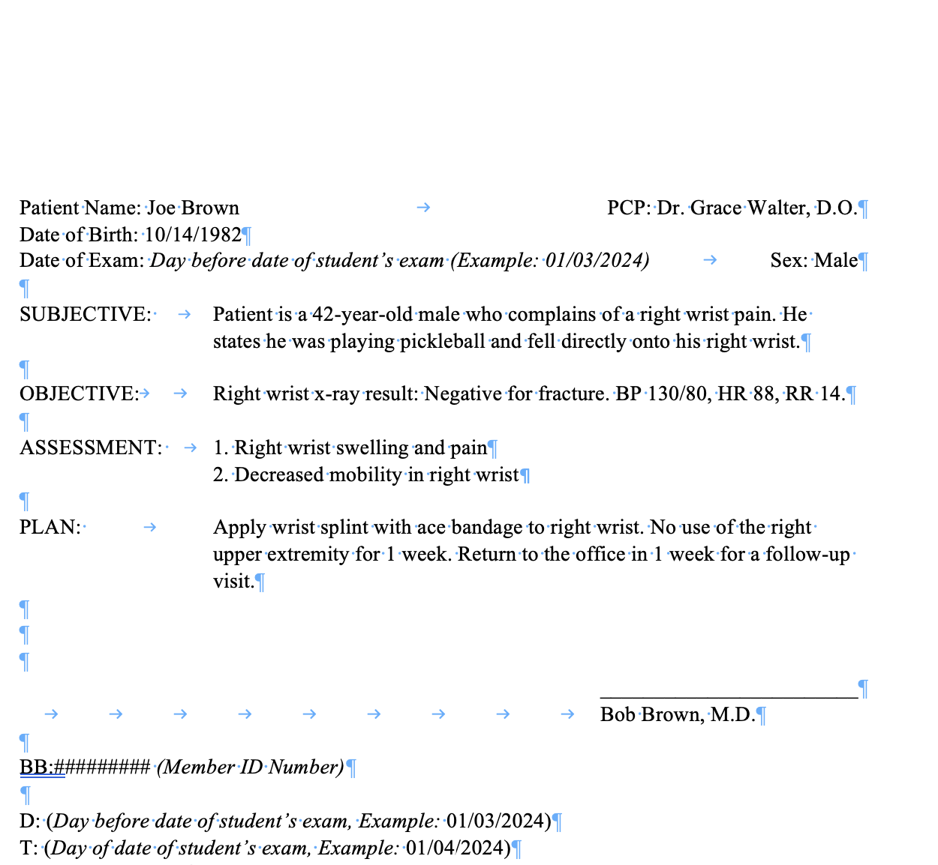
For graders: Refer to the Style and Reference for grading. Ensure that the top margin of the first page is 2.5 inches. For side margins 1 inch margins should be used. Physician signature line should be 2 inches long and right aligned.

